ASSIGNMENT 3:

**BENCHMARKING SIMPLE SORT:**

**Readings for different no. of element:**

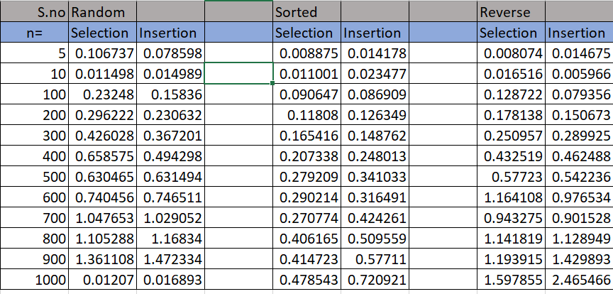

**Random Order:** 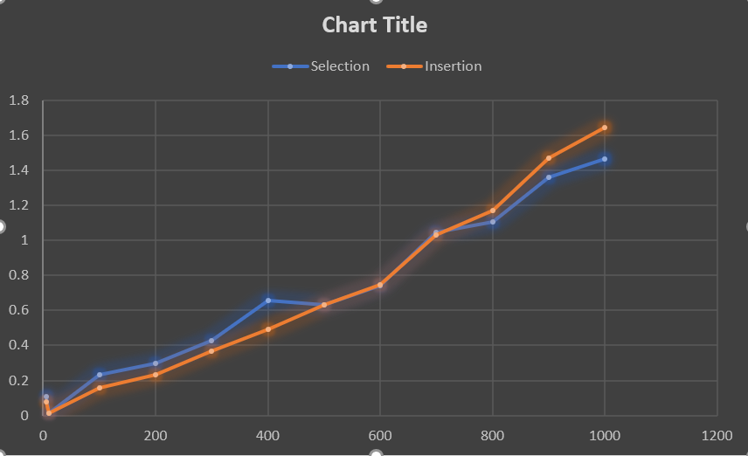

Conclusion for Random order:

1. For small values(n= 5): Insertion performs better than Selection.
2. For n(n=10 to n=500): Insertion sort performing better than Selection.
3. For bigger values (n=600 to n=100): Selection is performing better than Insertion.

**Sorted order:**

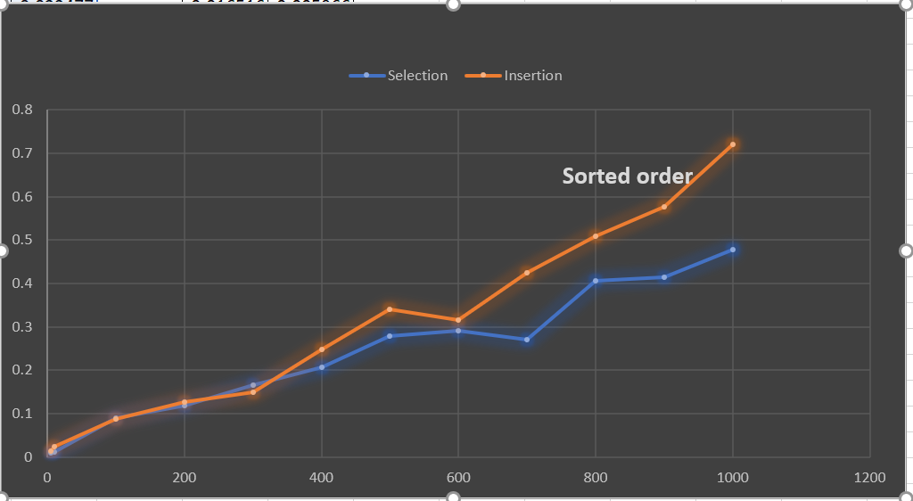

Conclusion for Sorted:

1. Selection sort is performing better than Insertion sort.
2. For large value of n the ratio of time taken selection to Insertion is decreasing.
3. **Reverse order:**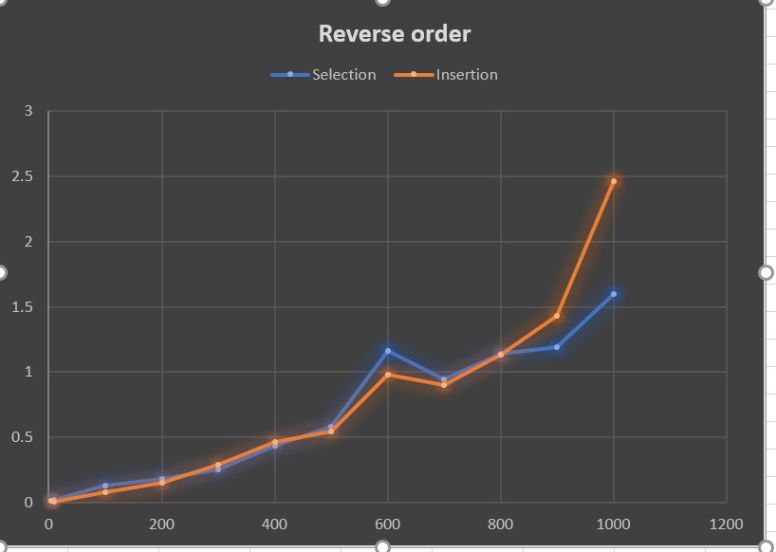

Conclusions for Reverse Order:

1. For small values of n (5 to 300 ) insertion is performing better.
2. For mid size values (n == 500 ) insertion is still giving better results
3. For Larger values of n (n=800 to 1000) selection sort is performing better with a great deviation.

**Tests:**

**SELECTION SORT:**

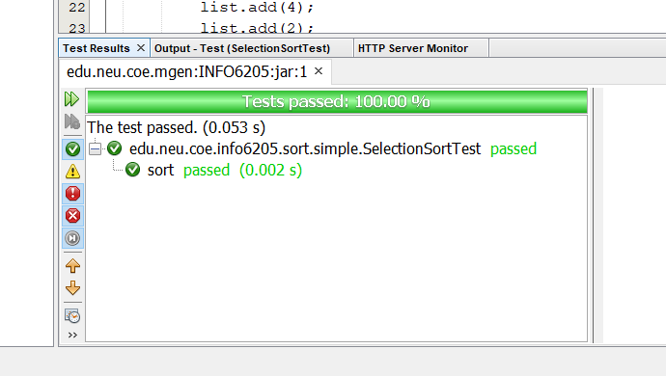

**INSERTION SORT**:

